Tugas 1 Individu Machine Learning

Nama : Syafri Wira Wicaksana

NIM : 226150100111018

Kelas : Machine Learning – A

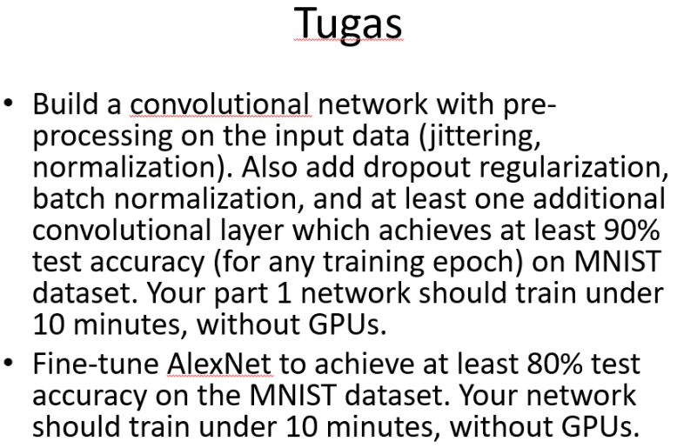

**Link Repository Github**

1. CNN

import time

import torch

import torch.nn as nn

import torchvision

import torchvision.datasets as dset

import torchvision.transforms as transforms

from torch.autograd import Variable

import torch.nn.functional as F

import torch.optim as optim

from sklearn.metrics import classification_report, confusion_matrix

# transform  = transforms.ToTensor()

trans_train = transforms.Compose([transforms.Lambda(lambda image: image.convert('RGB')),

                                  transforms.ColorJitter(brightness=0.05, contrast=0.8, saturation=0.02, hue=0.02),

                                  transforms.Resize((64,64)),

                                  transforms.ToTensor(),

                                  transforms.Normalize((0.5,), (1.0,))])

trans = transforms.Compose([transforms.Lambda(lambda image: image.convert('RGB')),

                            transforms.ColorJitter(brightness=0.05, contrast=0.8, saturation=0.02, hue=0.02),

                            transforms.Resize((64,64)),

                            transforms.ToTensor(),

                            transforms.Normalize((0.5,), (1.0,))])

train_data = dset.MNIST(root='../Data', train=True, download=True, transform=trans_train)

test_data = dset.MNIST(root='../Data', train=False, download=False, transform=trans)

print(train_data)

image,label=train_data[10]

print(image.shape)

print(label)

#loader data untuk training dan testing

batch_size = 64

train_loader = torch.utils.data.DataLoader(dataset=train_data,batch_size=batch_size,shuffle=True)

test_loader = torch.utils.data.DataLoader(dataset=test_data,batch_size=batch_size,shuffle=False)

class SimpleNet(nn.Module):

    def __init__(self, num_classes):

        super(SimpleNet, self).__init__()

        #bagian 1

        self.conv1 = nn.Conv2d(in_channels=3, out_channels=32, kernel_size=3)

        self.bn1 = nn.BatchNorm2d(32)

        self.relu1 = nn.ReLU(inplace=True)

        self.max_poo1 = nn.MaxPool2d(kernel_size = 2, stride = 2)

        self.conv2 = nn.Conv2d(in_channels=32, out_channels=32, kernel_size=3)

        self.bn2 = nn.BatchNorm2d(32)

        self.relu2 = nn.ReLU(inplace=True)

        self.max_poo2 = nn.MaxPool2d(kernel_size = 2, stride = 2)

        # bagian 2

        self.conv_layer3 = nn.Conv2d(in_channels=32, out_channels=64, kernel_size=3)

        self.bn3 = nn.BatchNorm2d(64)

        self.relu3 = nn.ReLU(inplace=True)

        self.max_poo3 = nn.MaxPool2d(kernel_size = 2, stride = 2)

        self.conv_layer4 = nn.Conv2d(in_channels=64, out_channels=64, kernel_size=3)

        self.bn4 = nn.BatchNorm2d(64)

        self.relu4 = nn.ReLU(inplace=True)

        self.max_poo4 = nn.MaxPool2d(kernel_size = 2, stride = 2)

        #bagian classifier

        self.fc1 = nn.Linear(256, 4096)

        # self.relu5 = nn.ReLU(inplace=True)

        self.dropout1 = nn.Dropout(p=0.1)

        self.fc4 = nn.Linear(4096, num_classes)

        self.classifier = nn.Softmax(dim=1)

    def forward(self, x):

        out = self.conv1(x)

        out = self.bn1(out)

        out = self.relu1(out)

        out = self.max_poo1(out)

        out = self.conv2(out)

        out = self.bn2(out)

        out = self.relu2(out)

        out = self.max_poo2(out)

        out = self.conv_layer3(out)

        out = self.bn3(out)

        out = self.relu3(out)

        out = self.max_poo3(out)

        out = self.conv_layer4(out)

        out = self.bn4(out)

        out = self.relu4(out)

        out = self.max_poo4(out)

        out = out.view(out.size(0), -1) # mengubah dimensi tensor

        out = self.fc1(out)

        # out = self.relu5(out)

        out = self.dropout1(out)

        out = self.fc4(out)

        out = self.classifier(out)

        return out

model = SimpleNet(num_classes = 10)

model

def train(epoch):

    model.train()

    start_time = time.time()

    correct = 0

    for batch_idx, (data, target) in enumerate(train_loader):

        # if torch.cpu.is_available():

        #     data, target = data.cpu(), target.cpu()

        data, target = Variable(data), Variable(target)

        optimizer.zero_grad()

        output = model(data)

        loss = F.cross_entropy(output, target)

        train_losses.append(loss.item())

        loss.backward()

        optimizer.step()

        # Menghitung jumlah prediksi yang benar

        pred = output.data.max(1, keepdim=True)[1]

        correct += pred.eq(target.data.view_as(pred)).cpu().sum()

        if batch_idx % 100 == 0:

            print('\rEpoch: {} {:.0f}%\t     Loss: {:.6f}'.format(

                epoch,

                100. * batch_idx / len(train_loader), loss.item()), end='')

    end_time = time.time()

    print("\nLama waktu Training pada epoch {}: {} Menit".format(epoch, ((end_time - start_time)/60)))

    # Menghitung dan mencetak akurasi pelatihan

    train_accuracy = 100. * correct / len(train_loader.dataset)

    train_akurasi.append(train_accuracy)

    print('Akurasi pada Training pada epoch {}: {:.2f}%'.format(epoch, train_accuracy))

def test():

    model.eval()

    test_loss = 0

    correct = 0

    for data, target in test_loader:

        # if torch.cpu.is_available():

        #     data, target = data.cpu(), target.cpu()

        data, target = Variable(data), Variable(target)

        output = model(data)

        test_loss += F.cross_entropy(output, target, reduction='sum').item()

        pred = output.data.max(1, keepdim=True)[1] # get the index of the max log-probability

        correct += pred.eq(target.data.view_as(pred)).long().cpu().sum()

    test_loss /= len(test_loader.dataset)

    test_losses.append(test_loss)

    acc=100. * float(correct.to(torch.device('cpu')).numpy())

    print('\nHasil Testing: Rata-Rata loss: {:.4f}, Akurasi: {:.4f}%\n'.format(

        test_loss, acc / len(test_loader.dataset)))

    test_accuracy.append(acc / len(test_loader.dataset))

optimizer = optim.SGD(model.parameters(), lr=0.01)

train_losses = []

test_losses =[]

test_accuracy = []

train_akurasi = []

for epoch in range(1, 2):

    train(epoch)

    test()

# membuat prediksi dan ground truth labels

y_pred = []

y_true = []

for data, target in test_loader:

    data, target = Variable(data), Variable(target)

    output = model(data)

    pred = output.data.max(1, keepdim=True)[1].cpu().numpy().squeeze()

    y_pred.extend(pred)

    y_true.extend(target.data.cpu().numpy())

# membuat confusion matrix dan classification report

conf_mat = confusion_matrix(y_true, y_pred)

class_report = classification_report(y_true, y_pred)

print('Confusion Matrix:')

print(conf_mat)

print('Classification Report:')

print(class_report)

**Arsitektur model**

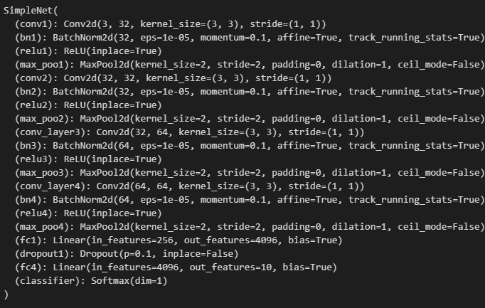

**Hasil Pelatihan**

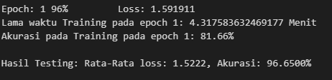

**Hasil *Confusion Matrix***

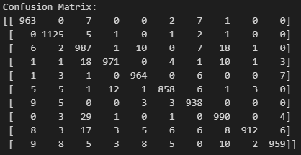

**Hasil Akurasi**

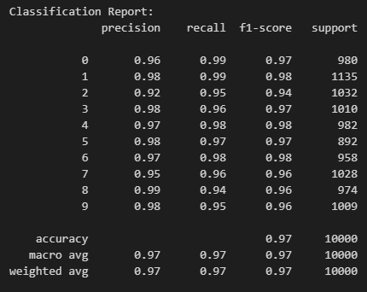

**97%**

1. **Alexnet + Finetune**

**Load model**

#inisialisasi Model AlexNet

Fitur = 10

model1 = torchvision.models.alexnet(weights='AlexNet_Weights.DEFAULT')

model1.classifier.add_module('6', nn.Linear(in_features=4096, out_features=Fitur))

model1.classifier.add_module('7', nn.Softmax(dim=1))

model = model1

model

**Fine tune pada model**

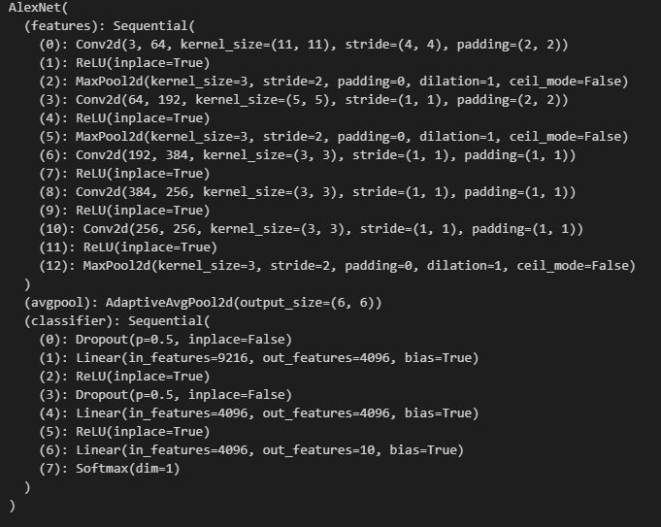

**Hasil Training**

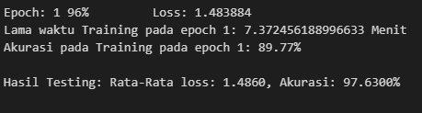

**Confussion Matrix**

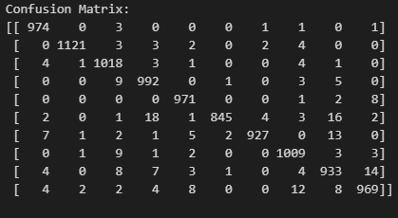

**Hasil Akurasi**

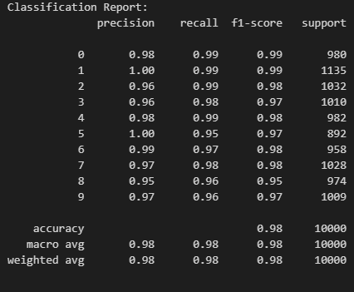

Akurasi 98%